FILE 03 — PARIKSHAK SOLUTION, IMPLEMENTATION & IMPACT
03_PARIKSHAK_SOLUTION_IMPLEMENTATION_AND_IMPACT

PARIKSHAK — Solution, Implementation & Impact
Core Question: What exactly are we proposing, how does it work, how can it be built, and what outcomes can it produce?

PART A — Solution Architecture & Methodology

1. Solution Statement
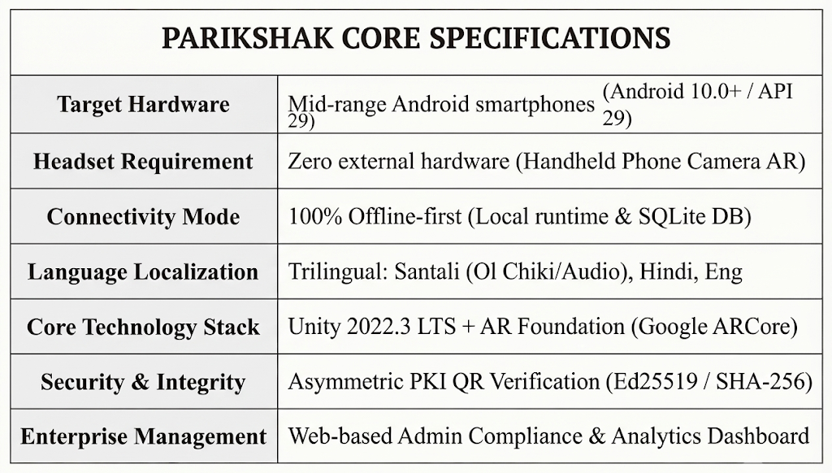
PARIKSHAK is an offline-first, mobile Augmented Reality (AR) vocational training and safety certification platform that runs on standard mid-range Android smartphones (Android 10+, no external headset required). It transforms conventional safety instruction into interactive, spatial, and assessment-based learning tailored to the linguistic and infrastructural realities of industrial workers across Jharkhand's mining, steel, and mica belts.

2. Training Domains
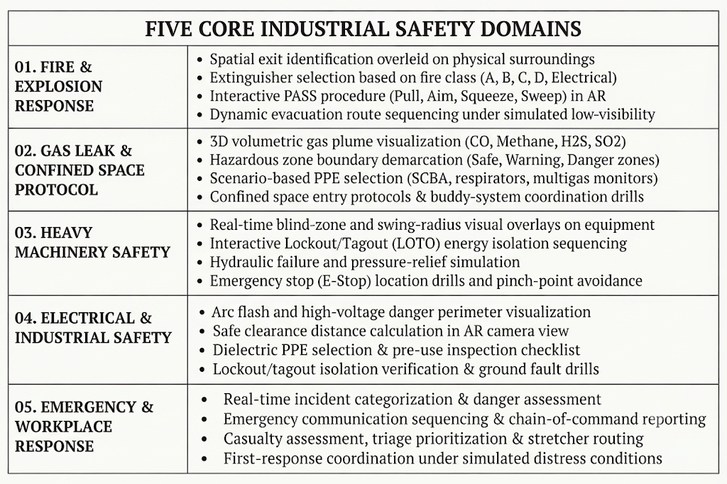
PARIKSHAK delivers modular, chapter-based training across five core industrial safety domains, designed around critical workplace hazards:

3. Learning Methodology
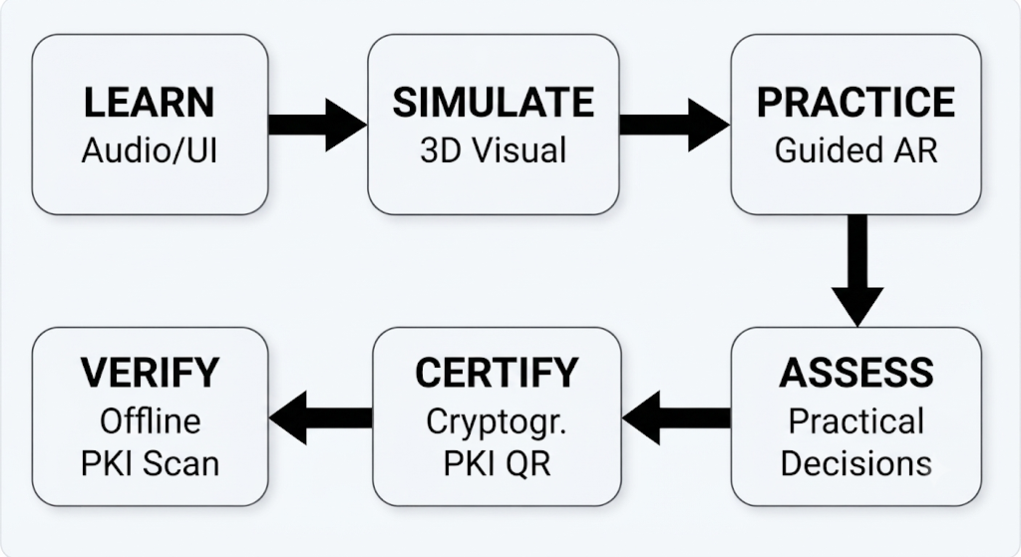
PARIKSHAK operates on a structured, six-stage pedagogical pipeline that transitions the worker from basic comprehension to demonstrated practical competence.
- LEARN (Instructional Foundation): High-clarity visual diagrams and audio-guided explanations in Hindi or Santali deliver core safety concepts without text dependence.
- SIMULATE (Contextual Projection): AR engine projects 3D spatial models (gas leaks, machine blind zones, fire hazards) directly into the worker's physical surroundings via the phone camera.
- PRACTICE (Guided Interaction): Workers perform step-by-step interactive actions with real-time feedback (e.g., pulling extinguisher pin, setting isolation locks).
- ASSESS (Evaluative Decision-Making): Unassisted assessment testing practical spatial judgment, sequence accuracy, and hazard identification under time limits.
- CERTIFY (Cryptographic Generation): Upon achieving the passing threshold, the local engine generates a digitally signed, tamper-proof QR code credential.
- VERIFY (Zero-Connectivity Audit): Supervisors scan the worker's QR code using an offline verification app to confirm identity, module completion, and authenticity in seconds.

4. Chapter Structure
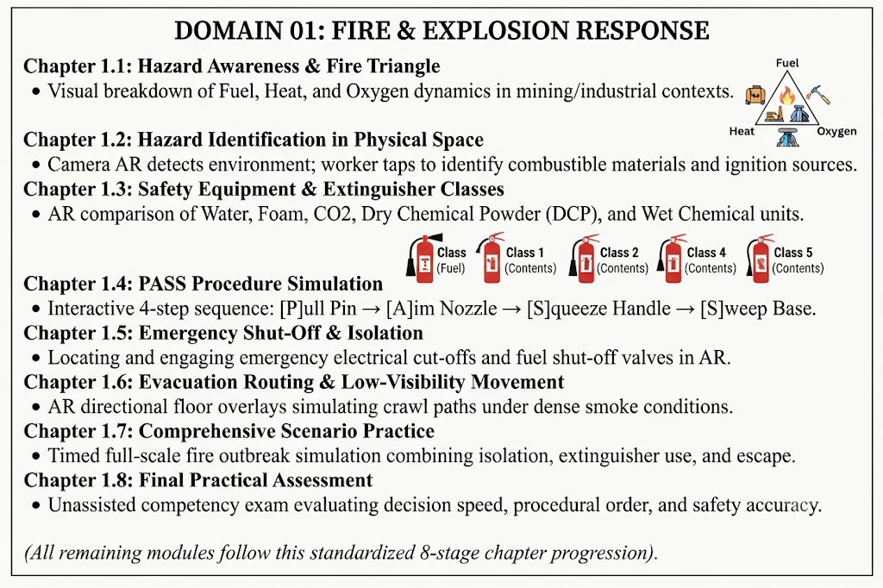
Each domain module is subdivided into progressive, bite-sized chapters. Below is the chapter breakdown for Domain 01: Fire & Explosion Response:

5. Assessment Engine
PARIKSHAK fundamentally shifts the paradigm of vocational evaluation:
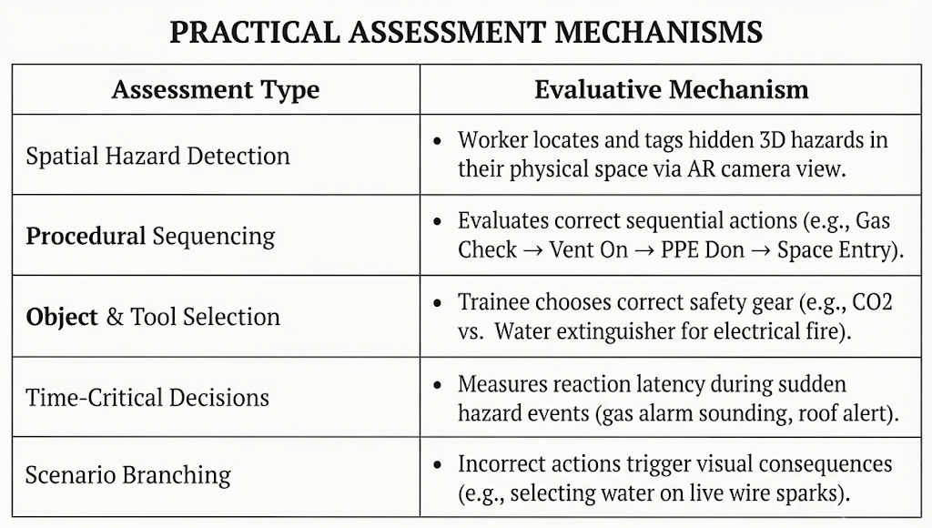
Core Pedagogical Principle: PARIKSHAK evaluates what the worker can do, not only what the worker can recall.
- Scoring Engine: Minimum passing threshold is set at 80% overall score, requiring 100% accuracy on non-negotiable critical safety steps (e.g., gas atmospheric testing before confined space entry).
- Attempt Tracking: Local SQLite database logs timestamped interaction coordinates, reaction times (in milliseconds), error counts, and completion status.

6. Certification & Cryptographic Verification
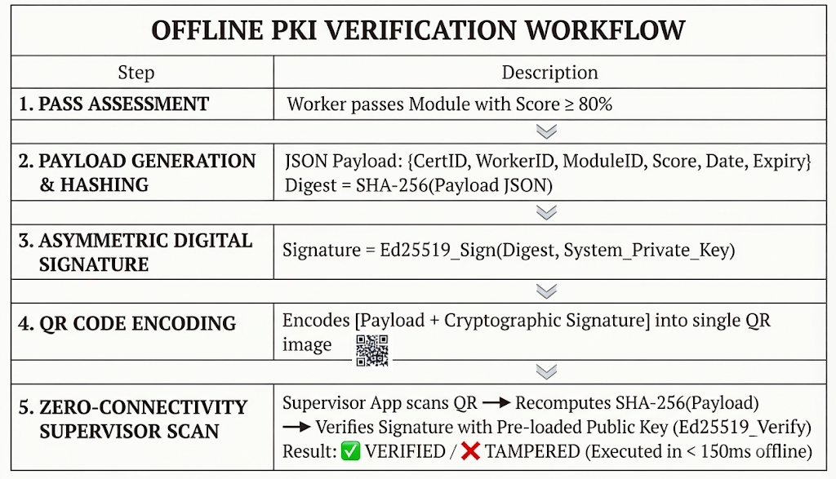
PARIKSHAK implements an offline Public Key Infrastructure (PKI) system to issue tamper-proof, verifiable digital credentials without requiring cloud connectivity. [S07] [S08]
QR Payload Structure
JSON
{
"cert_id": "PRK-2026-JH-08492",
"worker_id": "WRK-CCL-8831",
"module_id": "MOD-01-FIRE-RESP",
"score": 92.5,
"issue_ts": 1772668800,
"valid_until": 1804204800,
"issuer_id": "PARIKSHAK-CCL-RAJR畴PPA",
"sig": "3a8f7c9e2b1d...[Ed25519 Signature Bytes]"
}
Important Statutory Disclaimer: PARIKSHAK digital credentials are designed to provide an unalterable, verifiable record of demonstrated training competence. They complement and integrate with authorized DGMS / GVTC vocational training programs and do not claim to unilaterally replace statutory regulatory certificates without institutional approval. [S03]

7. Offline Architecture
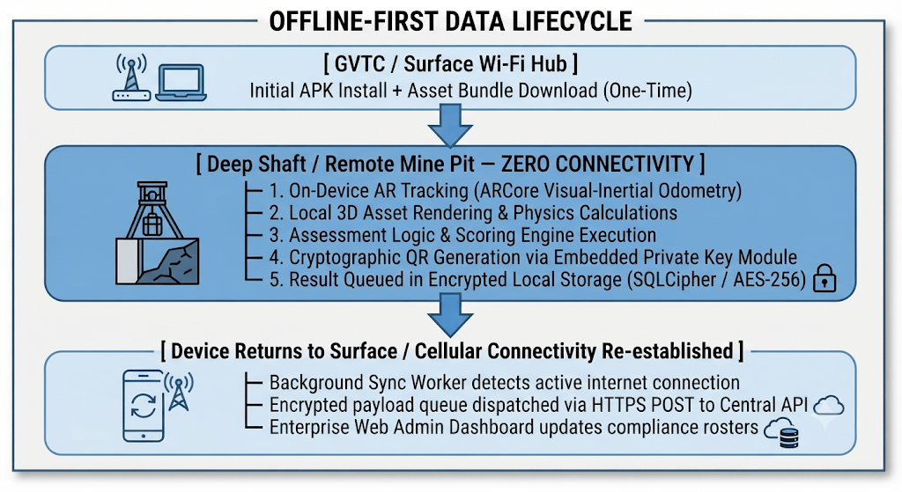
Industrial mines in Jharkhand suffer from complete network blackouts in underground shafts and remote pits. PARIKSHAK operates on a 100% Offline-First Architecture: [S06] [S07]

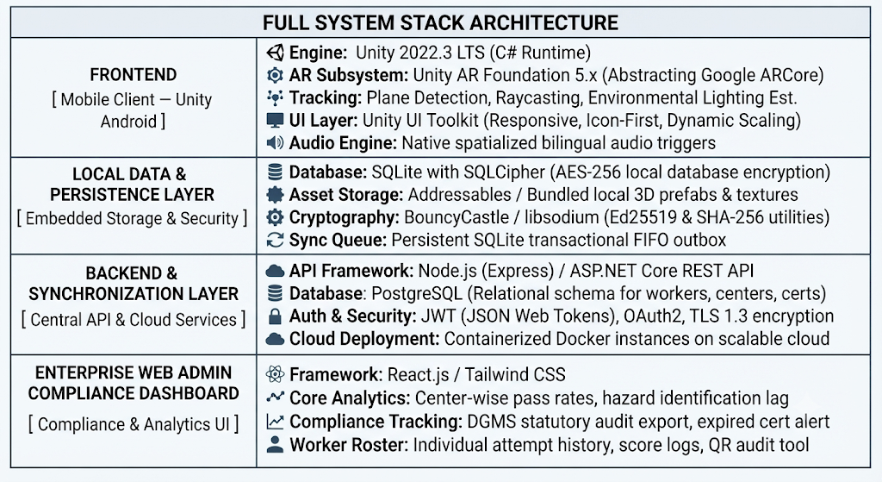
8. Technical Architecture & System Specifications

9. Language & Accessibility Design
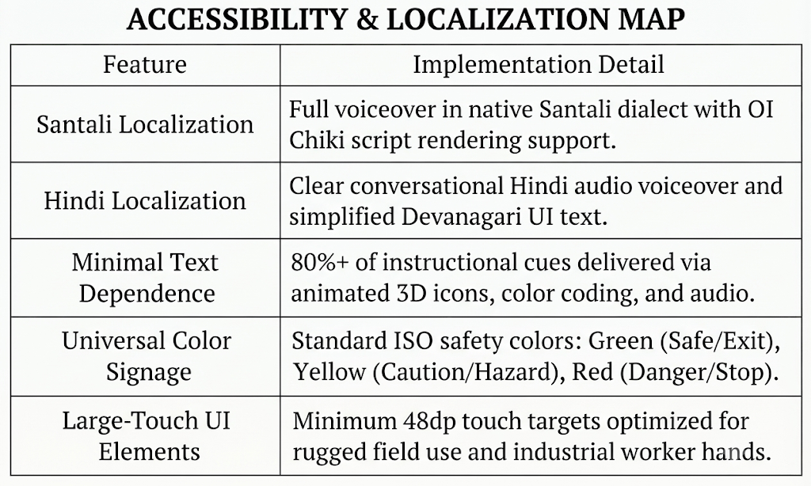
To eliminate the severe literacy and language barriers documented in Jharkhand's mining belts, PARIKSHAK implements an Accessibility-First Design: [S01] [S03]

10. Worker Journey
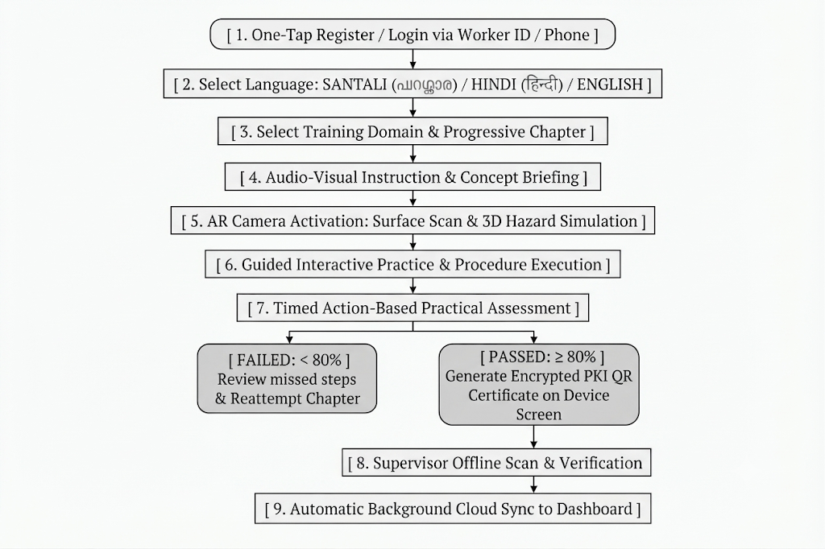
The end-to-end user journey is designed for maximum simplicity:

PART B — Impact, Scalability & Risk Analysis

11. Impact Research & Quantified Outcomes
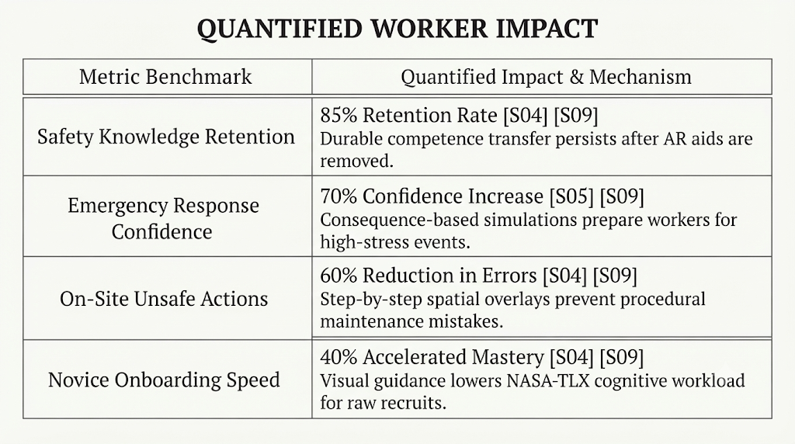
The deployment of PARIKSHAK produces measurable improvements across four core dimensions:
Categorized Multi-Dimensional Impact
1. Worker Safety & Ergonomics
- Safe Exposure to High-Risk Hazards: Trainees experience gas leaks, coal seam fires, and blind-zone hazards in 3D AR without physical risk. [S04] [S05]
- Cognitive Augmentation: NASA-TLX cognitive load evaluations confirm AR guidance imposes mental workload equal to or lower than paper manuals during complex tasks. [S04]
- Mitigating Health Hazards: Providing hazard-free onboarding removes workers from early toxic dust and gas exposures, protecting them from respiratory illnesses. [S01] [S02]
2. Training Access & Inclusivity
- Reaching the 700,000 Informal Workers: Standalone Android APK democratizes access for the informal mining workforce excluded from statutory training. [S01] [S03]
- Eliminating the 75% Training Deficit: Bypasses physical classroom capacity constraints, providing pre-job skilling to the ~75% of miners currently unreached. [S03]
- Linguistic Empowerment: Santali and Hindi voiceovers ensure equal access for marginalized Adivasi and Dalit communities. [S01] [S03]
3. Operational & Financial ROI for Mining Organizations
- Slashing Equipment Downtime Losses: Unplanned downtime costs USD 180,000 per incident and up to USD 130,000 per hour ($60B global annual loss). AR maintenance guidance prevents costly procedural errors. [S04]
- CapEx Elimination: Utilizing existing worker smartphones avoids expensive enterprise VR headsets ($500–$3,500+ per unit) and air-conditioned simulation labs. [S04]
- Mitigating Skilled Labor Shortages: Accelerates onboarding to bridge the gap left by an aging workforce (72% over 35) and high recruitment difficulty (86% of executives). [S04]
4. Credential Integrity & Career Mobility
- Recognition of Prior Learning (RPL): Provides informal workers with portable, unforgeable digital credentials to qualify for formal, safer employment. [S03]
- Audit-Ready Governance: Asymmetric PKI QR codes give DGMS inspectors and supervisors instant, offline-verifiable compliance records. [S07] [S08]

12. Scalability & Just Transition Roadmap
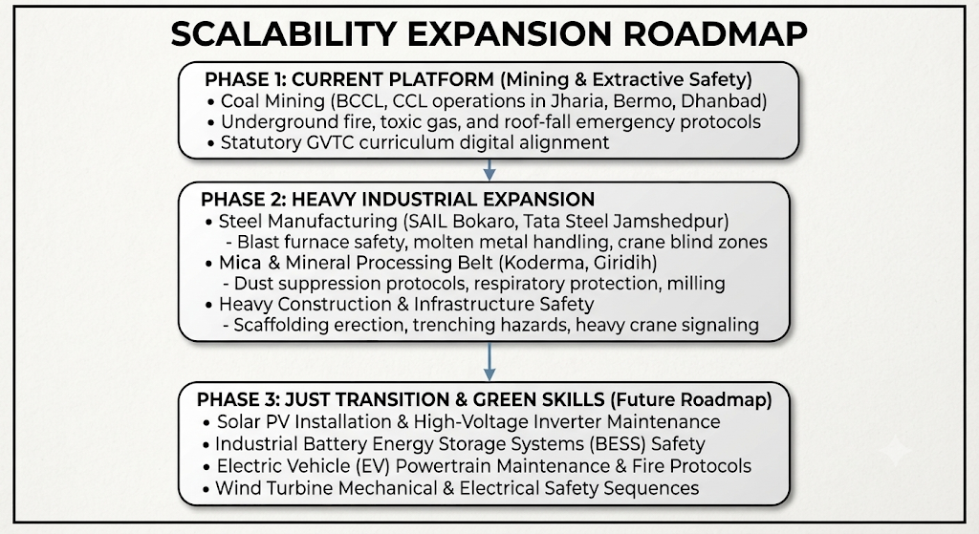
PARIKSHAK's modular C# and Addressables architecture allows frictionless expansion across additional heavy industries and clean-energy sectors:

Strategic Just Transition Alignment: As Jharkhand's Just Transition Task Force plans for long-term coal phase-downs, PARIKSHAK can deliver rapid, certified reskilling to transition displaced coal miners into certified clean-energy technicians. [S10]

13. Technical Risks, Limitations & Mitigation Strategies
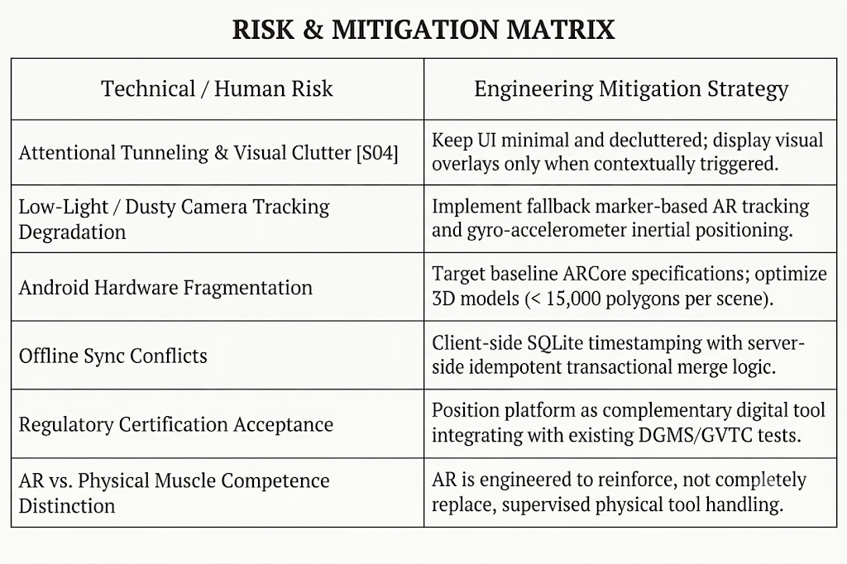
To ensure engineering rigor, PARIKSHAK explicitly accounts for operational risks and technical constraints:

